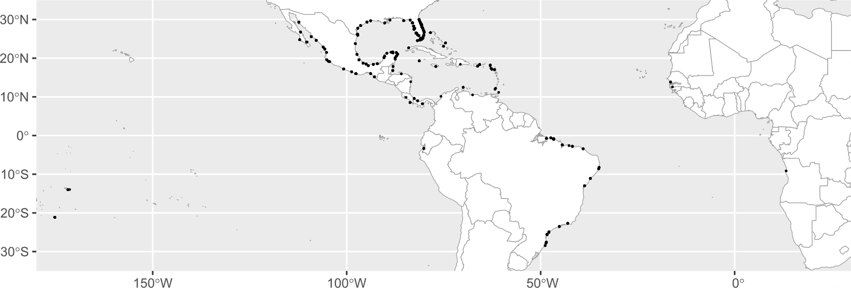
FIGURE 1 Map showing sample locations of the datasets used in this study (circles)

